Name : Syukur Sidiq Nur Alam Cohort : BDSE06-UIF-0922

1. Home Page

home page is the first look at this car website

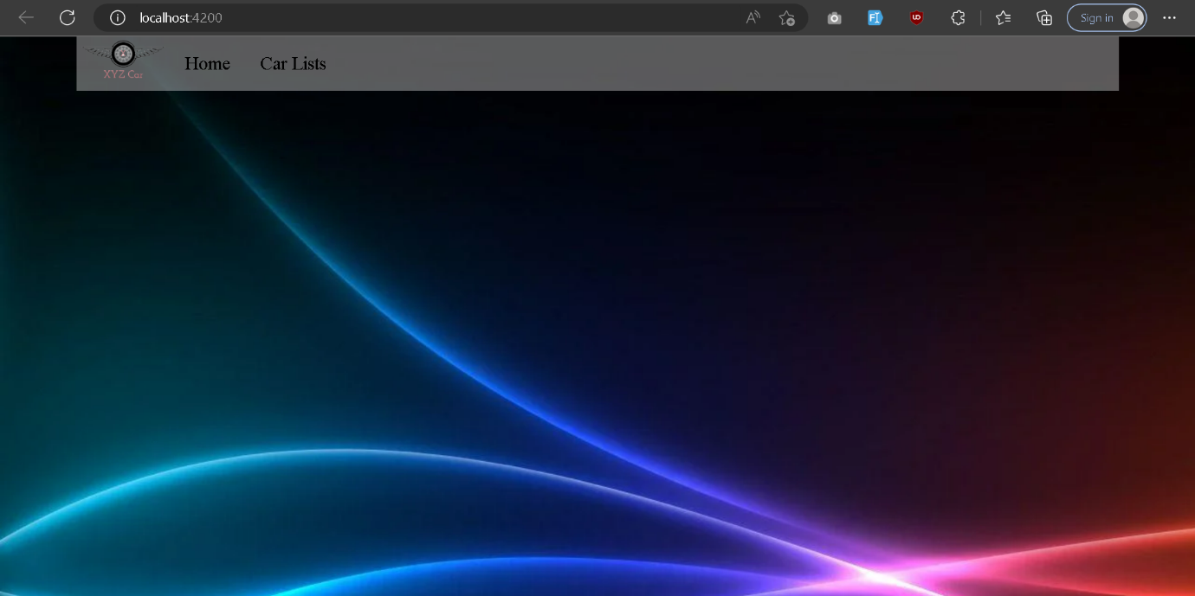

1. Car List

car list. is a view containing a list of available cars

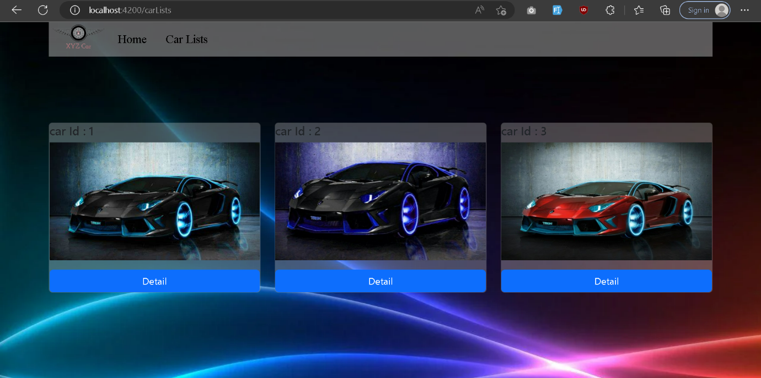

3.Car Detail

car details. contains the contents of the details from the previous selection in the car list

